Assignment 8
Student: Abdimutalip Aidana
Group: SE 2419
Part 1: Home Section
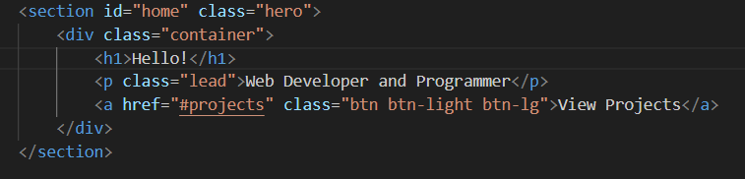
Made navigation menu and hero section with purple gradient background. Added title and button.
Part 2: About Section
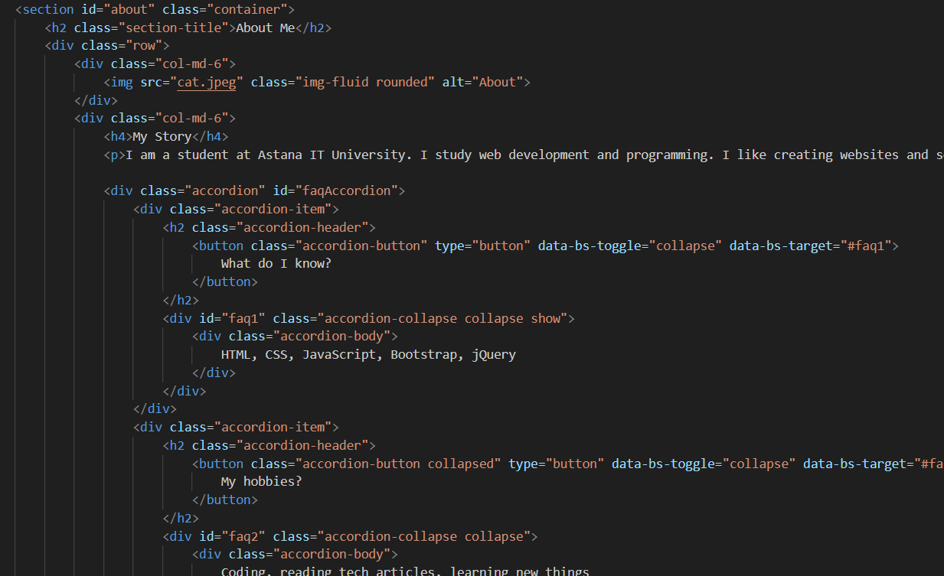
Added photo, text about myself, and accordion with 2 questions (What do I know, My hobbies).
Part 3: Projects Section
Created 6 project cards with filter buttons (All, Web, Other). Added modal window for details. Filter works with jQuery.
Part 4: Skills Section
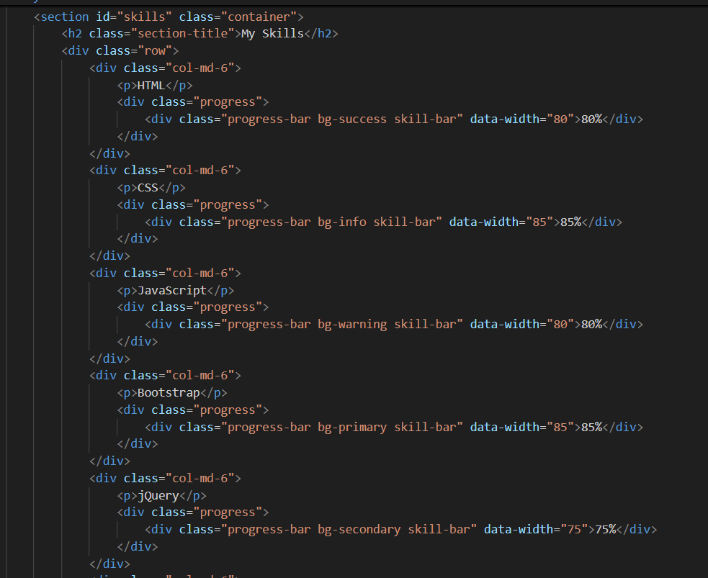
Made 6 progress bars: HTML 90%, CSS 85%, JavaScript 80%, Bootstrap 85%, jQuery 75%, Python 70%. Bars animate when scrolling.
Part 5: Contact Section
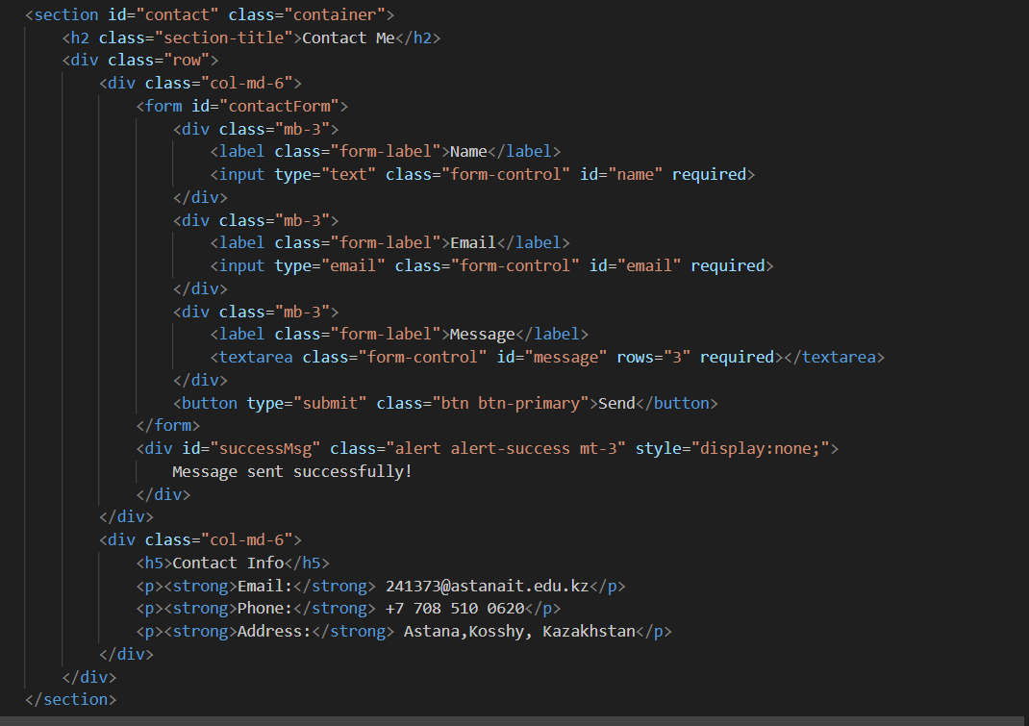
Created contact form with validation (name, email, message). Shows success message after submit. Added contact info.
Technologies Used
HTML5: Forms, semantic tags
CSS3: Gradient, transitions, hover effects
Bootstrap 5: Grid (col-md-4, col-md-6), navbar, cards, modal, accordion, progress bars
JavaScript: Form validation
jQuery: Filter projects, animate progress bars, smooth scroll, slideDown/slideUp
Interactive Features
- Accordion - opens/closes FAQ
- Filter - shows/hides projects by category
- Modal - displays project details
- Progress bars - animate on scroll
- Form validation - checks required fields
- Success message - appears after submit
- Smooth scroll - navigation to sections
- Hover effects - cards move on hover
Responsive Design
Desktop: 3 columns (projects), 2 columns (other sections)
Tablet: 2 columns, hamburger menu
Mobile: 1 column, all sections stack
Used Bootstrap grid: container, row, col-md-4, col-md-6
Conclusion
Created portfolio website with 5 sections. All requirements met. Website works on all devices.

